Forward, Sixty-six
You’ll Get Your Wealth in Heaven
Presented by 1000ee, Lifty Gang, and Yellow Dial.
Released October 31st, 2026.
“You wanna meka cool keys?”
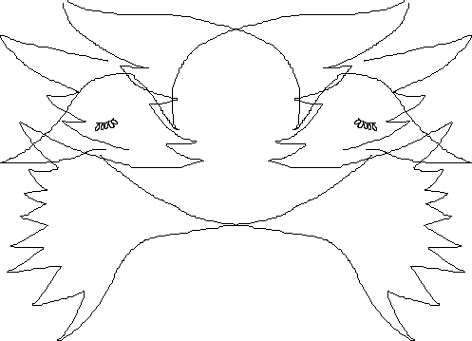
DJ Lifty Forward is her own lackey. Born November 11th, 2023, she has devoted her life to torturing herself, spreading the 1000ee.org mission of peace and love, and tearing this world apart. All the music on this disc was created over a period of more than 2 years, and tells the story of Mary and Josie discovering the lost power of radio, explains where Forward came from, turns flyer’s jacket into audio, reclaims Ralph Lauren for E.O.P. ‘26, develops connection with Forward’s loved ones, and ties up up up loose ends.
WHAT THIS DISC IS FOR:
- Strengthening device . . .
- Healing irrational fear . . .
- Naturaull floor . . .
- Bridge crossing . . .
- Cxyxhen’s pathway . . .
- Power dissolution . . .
- Early morning . . .
- Improving mental . . .
- Training floral skills!
WHAT THIS DISC IS NOT FOR:
- Anyone outside of the designated listening group . . .
- Falling apart . . .
- Being inconsiderate . . .
- Turning complacent . . .
- Bridge burning . . .
- Giving up . . .
- Never having a good time . . .
- Pat’chtel troubel . . .
- Self-isolation!
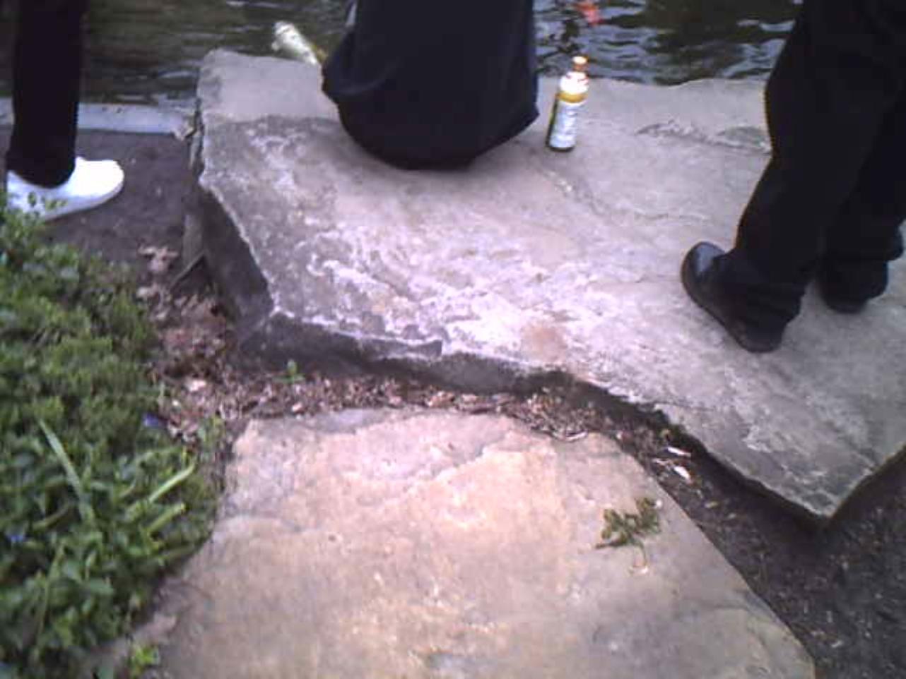1) Information

Programming, singing, and guitar by Sacha Lindich Hoffmann, 2024-2026.
Additional programming by Caroline, Sra, and Torso.
Pedal steel electric guitar by Serpuline.
Sampled vocals by JR Get Money (2010.)
"Am I still a star?" was written by James Keegan.
Created using FL Studio, Pxtone Collab, and Ableton Live.
Created in Oberlin, Yellowknife, Dublin, Highland, and Boise.
Thank you to everyone involved.
Apologies to Ketsy Nammals and Daisy Fountains, I could not make it work.

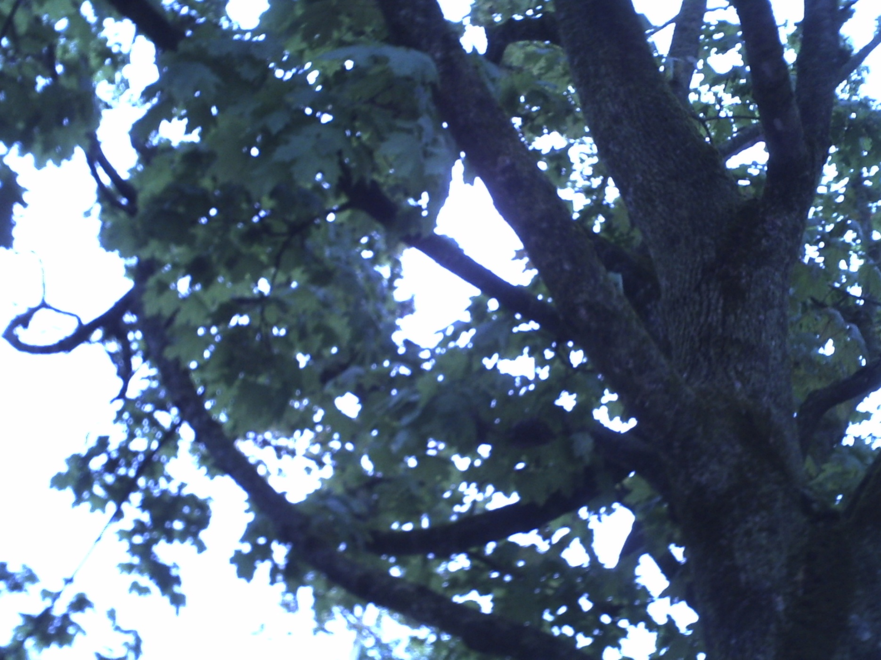
2) Past

Bereift of things easa cloisedten wall crushing us .Lonelyboat sailing at the harbor going out to sail at the harbour without a good wind but an elevated spirit, 17 young men all on the pier and I didn't want to be seen near them

Cold morningswillbe taken to long nights with this thing. Nothing so psychoactive as it - the radio. I don't understand how it works but I want to learn . I have to learn. That's how everything always worked -just like what they said . Just like my mom said.

I remember nights at your house turned to hoops and hoops on hils unlay school down there. I never wanted to go back . Never, not one bit. All games but even there are gone, just radio now.

A dream: Venice . Thoiusands of chgogrwe coats all run down the streets, the river, the rooftops, flying in Vs headed south : all talking about their purpose, who they are, their popularity . It left me with such unease

Places (Mirror) cold hand on a tear stained shoul,der . SHOULD"VE BOULDER UP THAT LANE to heaven! Stunned with her words I coulkdn't even believe my ears why she ould why would she say that with the knowledge of a broken heart

I packed myself up from that dread filled fevening and went home , Crystalline speaker dream waited for me all this time and I couldn't express how happy I was to seeeeeeeeeee it after so long

Empty light above dinner ta.le . Stale meal chewing . Jellied summer turned to leftovers in fall.

Sharpening another day stepped out in to the september wind and waited for the bus . The thogught of the radio still lingering in my mind una ble to get it out get it off at all .

Mary's hospital change and friends coldless and countless CAMe down with a sickness so awful . There was a dream of a broken lag ; she had liquids running into her and she was asleep quiet as ever. I wanted to wake her but the brown and its shades in her eye would n t lower

She has to come alive some how . It is a patch'tel trouble . . . as the marching band came while she was asleep . MISSING IT & MISSING OUT from an ope slumnber

Forthern through yellow and orange tints on the chair . Drifting off to sleep with the feeling of impending sorrysickness coursing through everything. Indian summer broke the frost and gave us all headaches and dizziness.

The foyer was never so small as to not hold a single chair and we had to put five or six of them in there.

Winter break was full and c if record cold . We stayed up with paper and nauture for days, decreasing in energy the further we went. I THREW UP a lOT of my person All over the couch several times . It couldn’t have been less than 700 times that I apologized after ward s.

Hold - captier. Five boxers (/ five boxes) .


3) Gallery

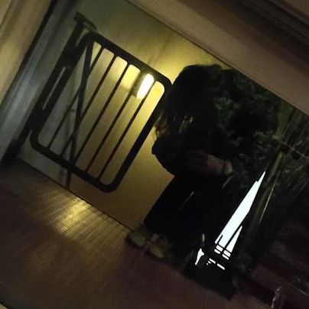
Sechka Morraw, age 19.

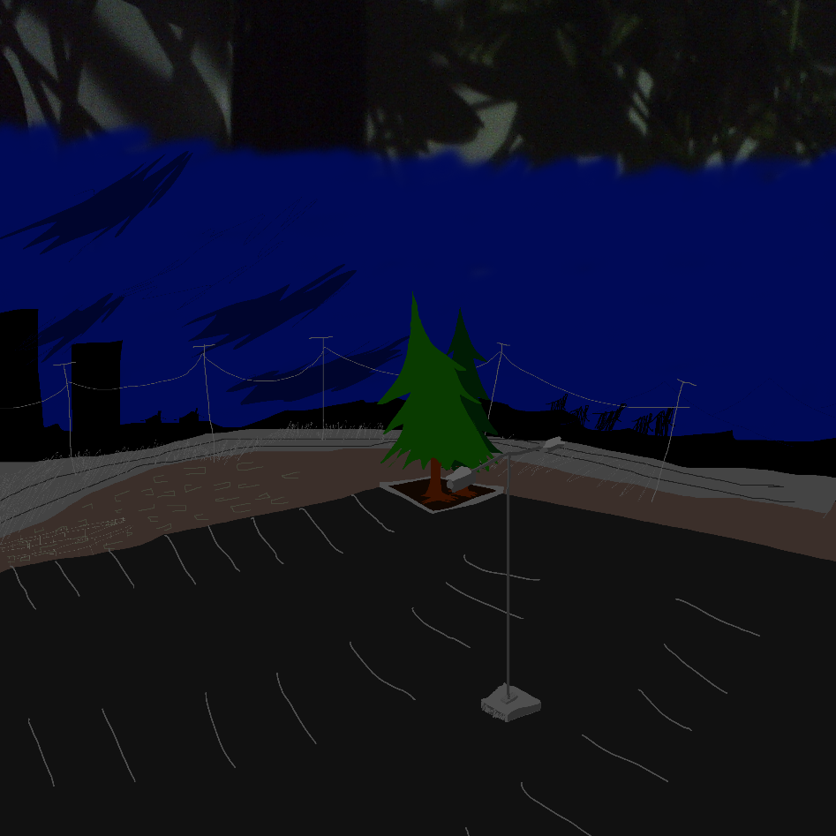
Her landscape.

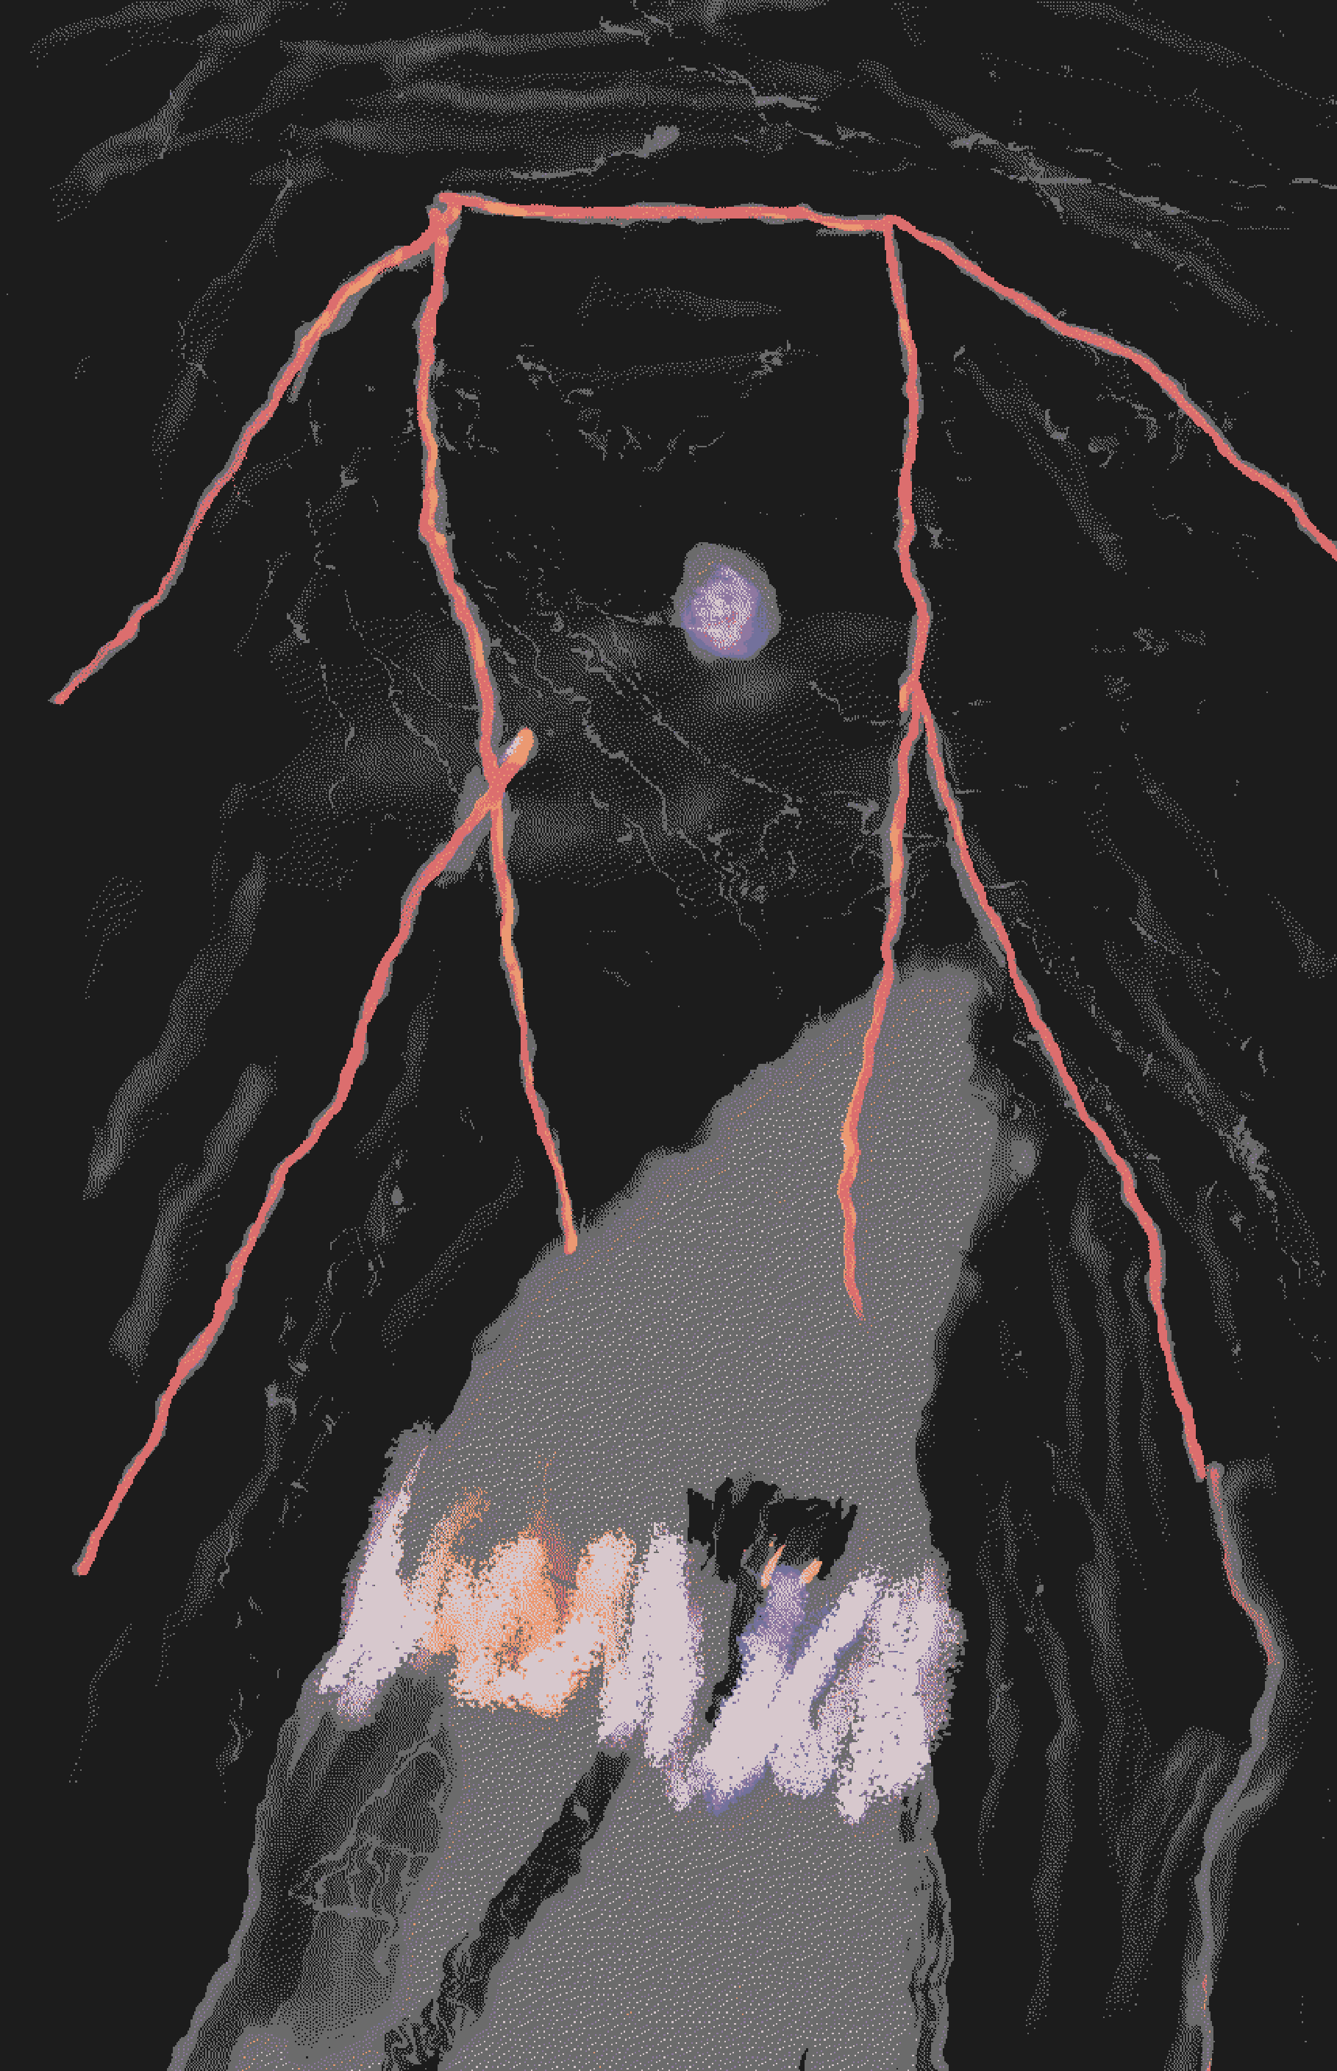
Cxyxhen’s pathway.

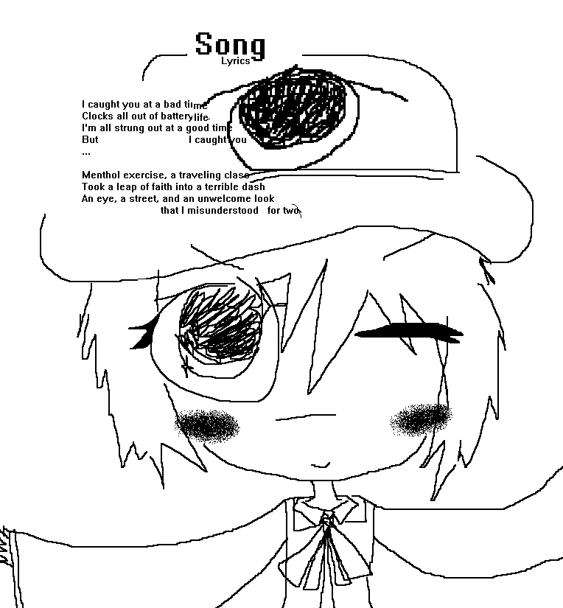
Chapel’s last little roe srash.

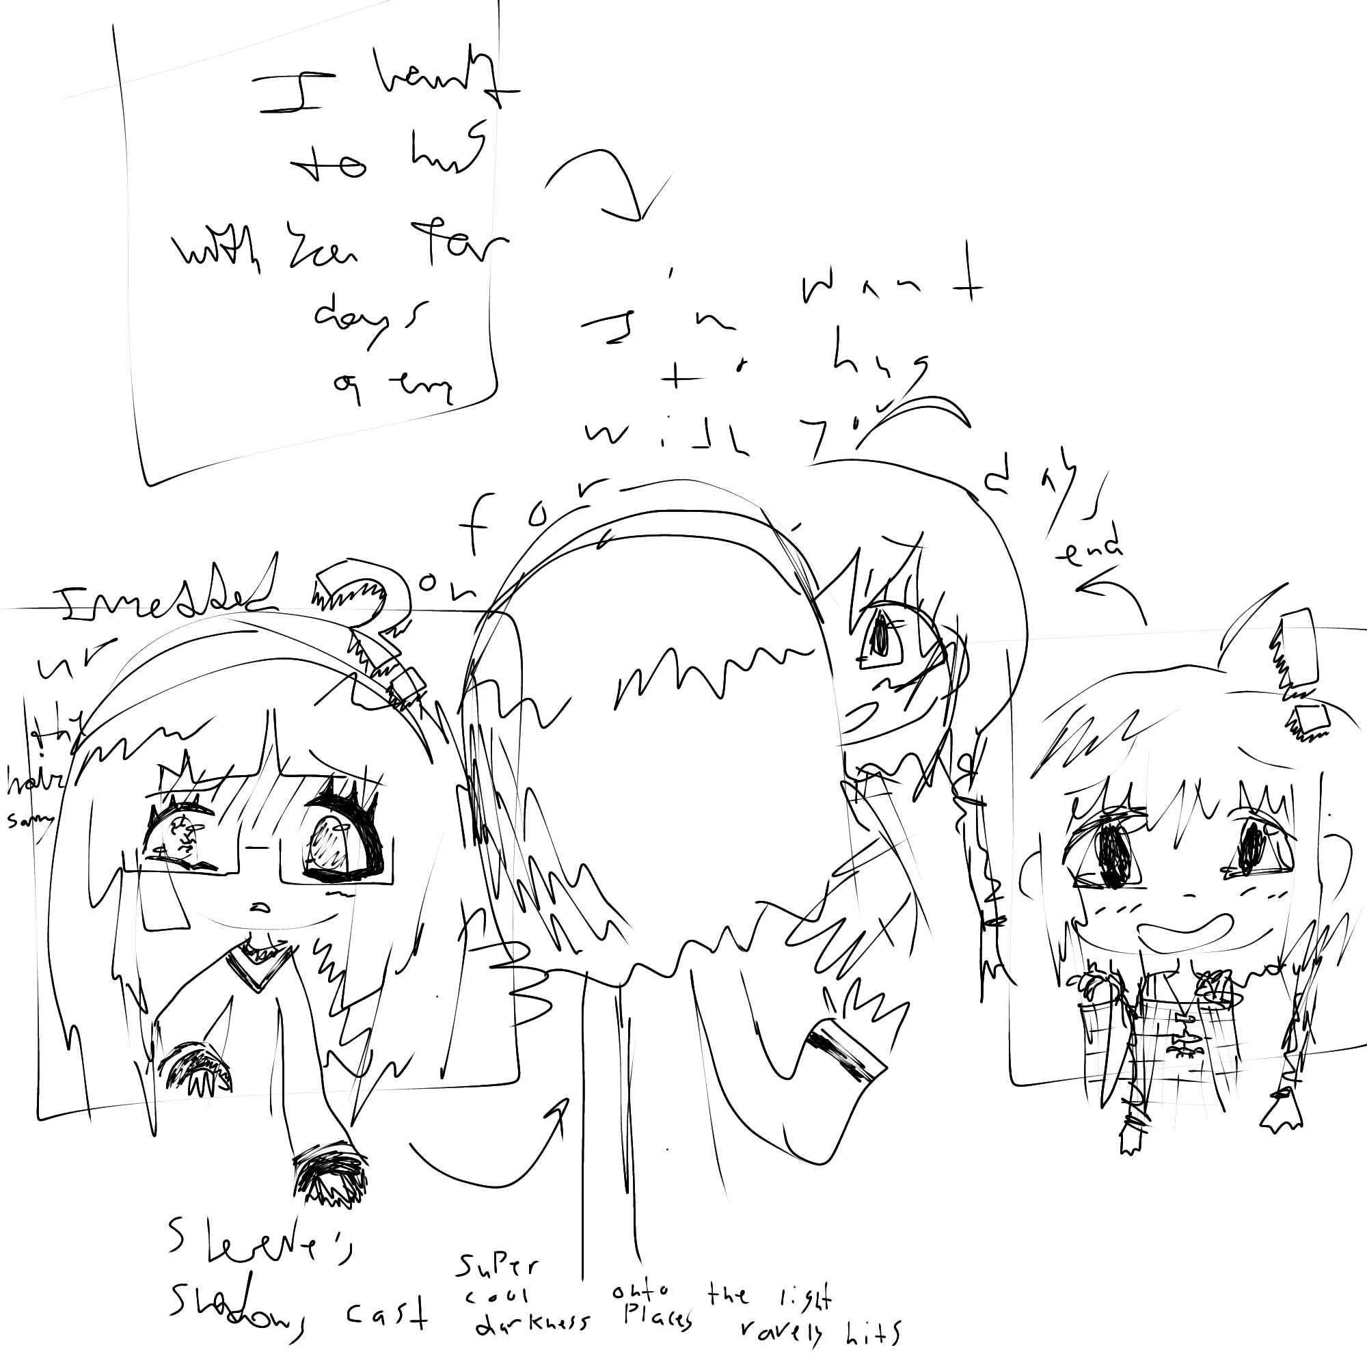
Desire.
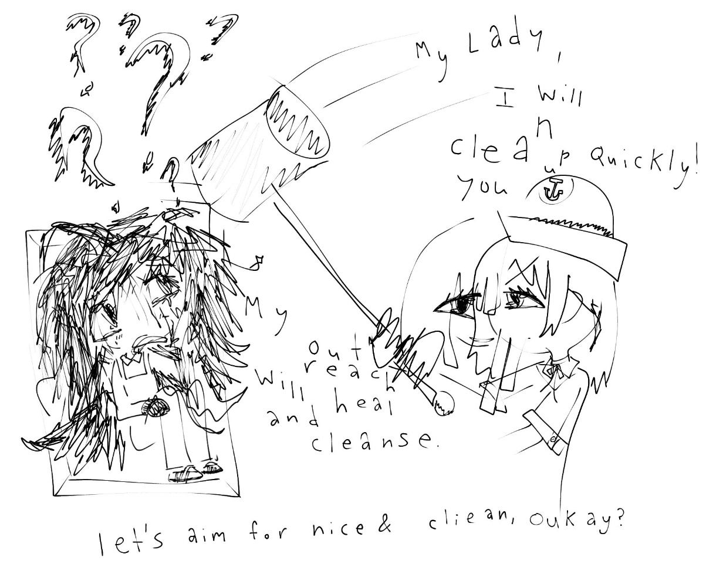
Clean my lady.

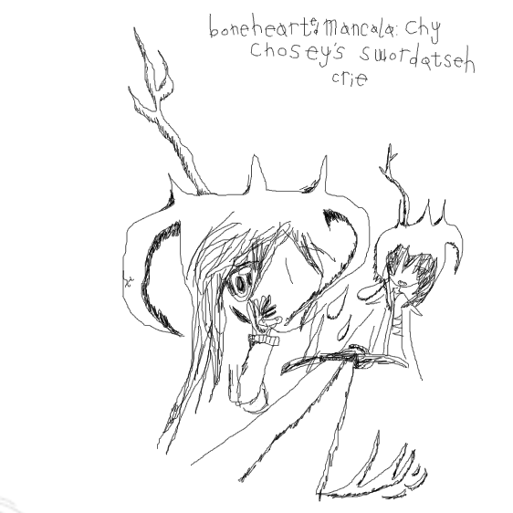
Taken from session with Sra.

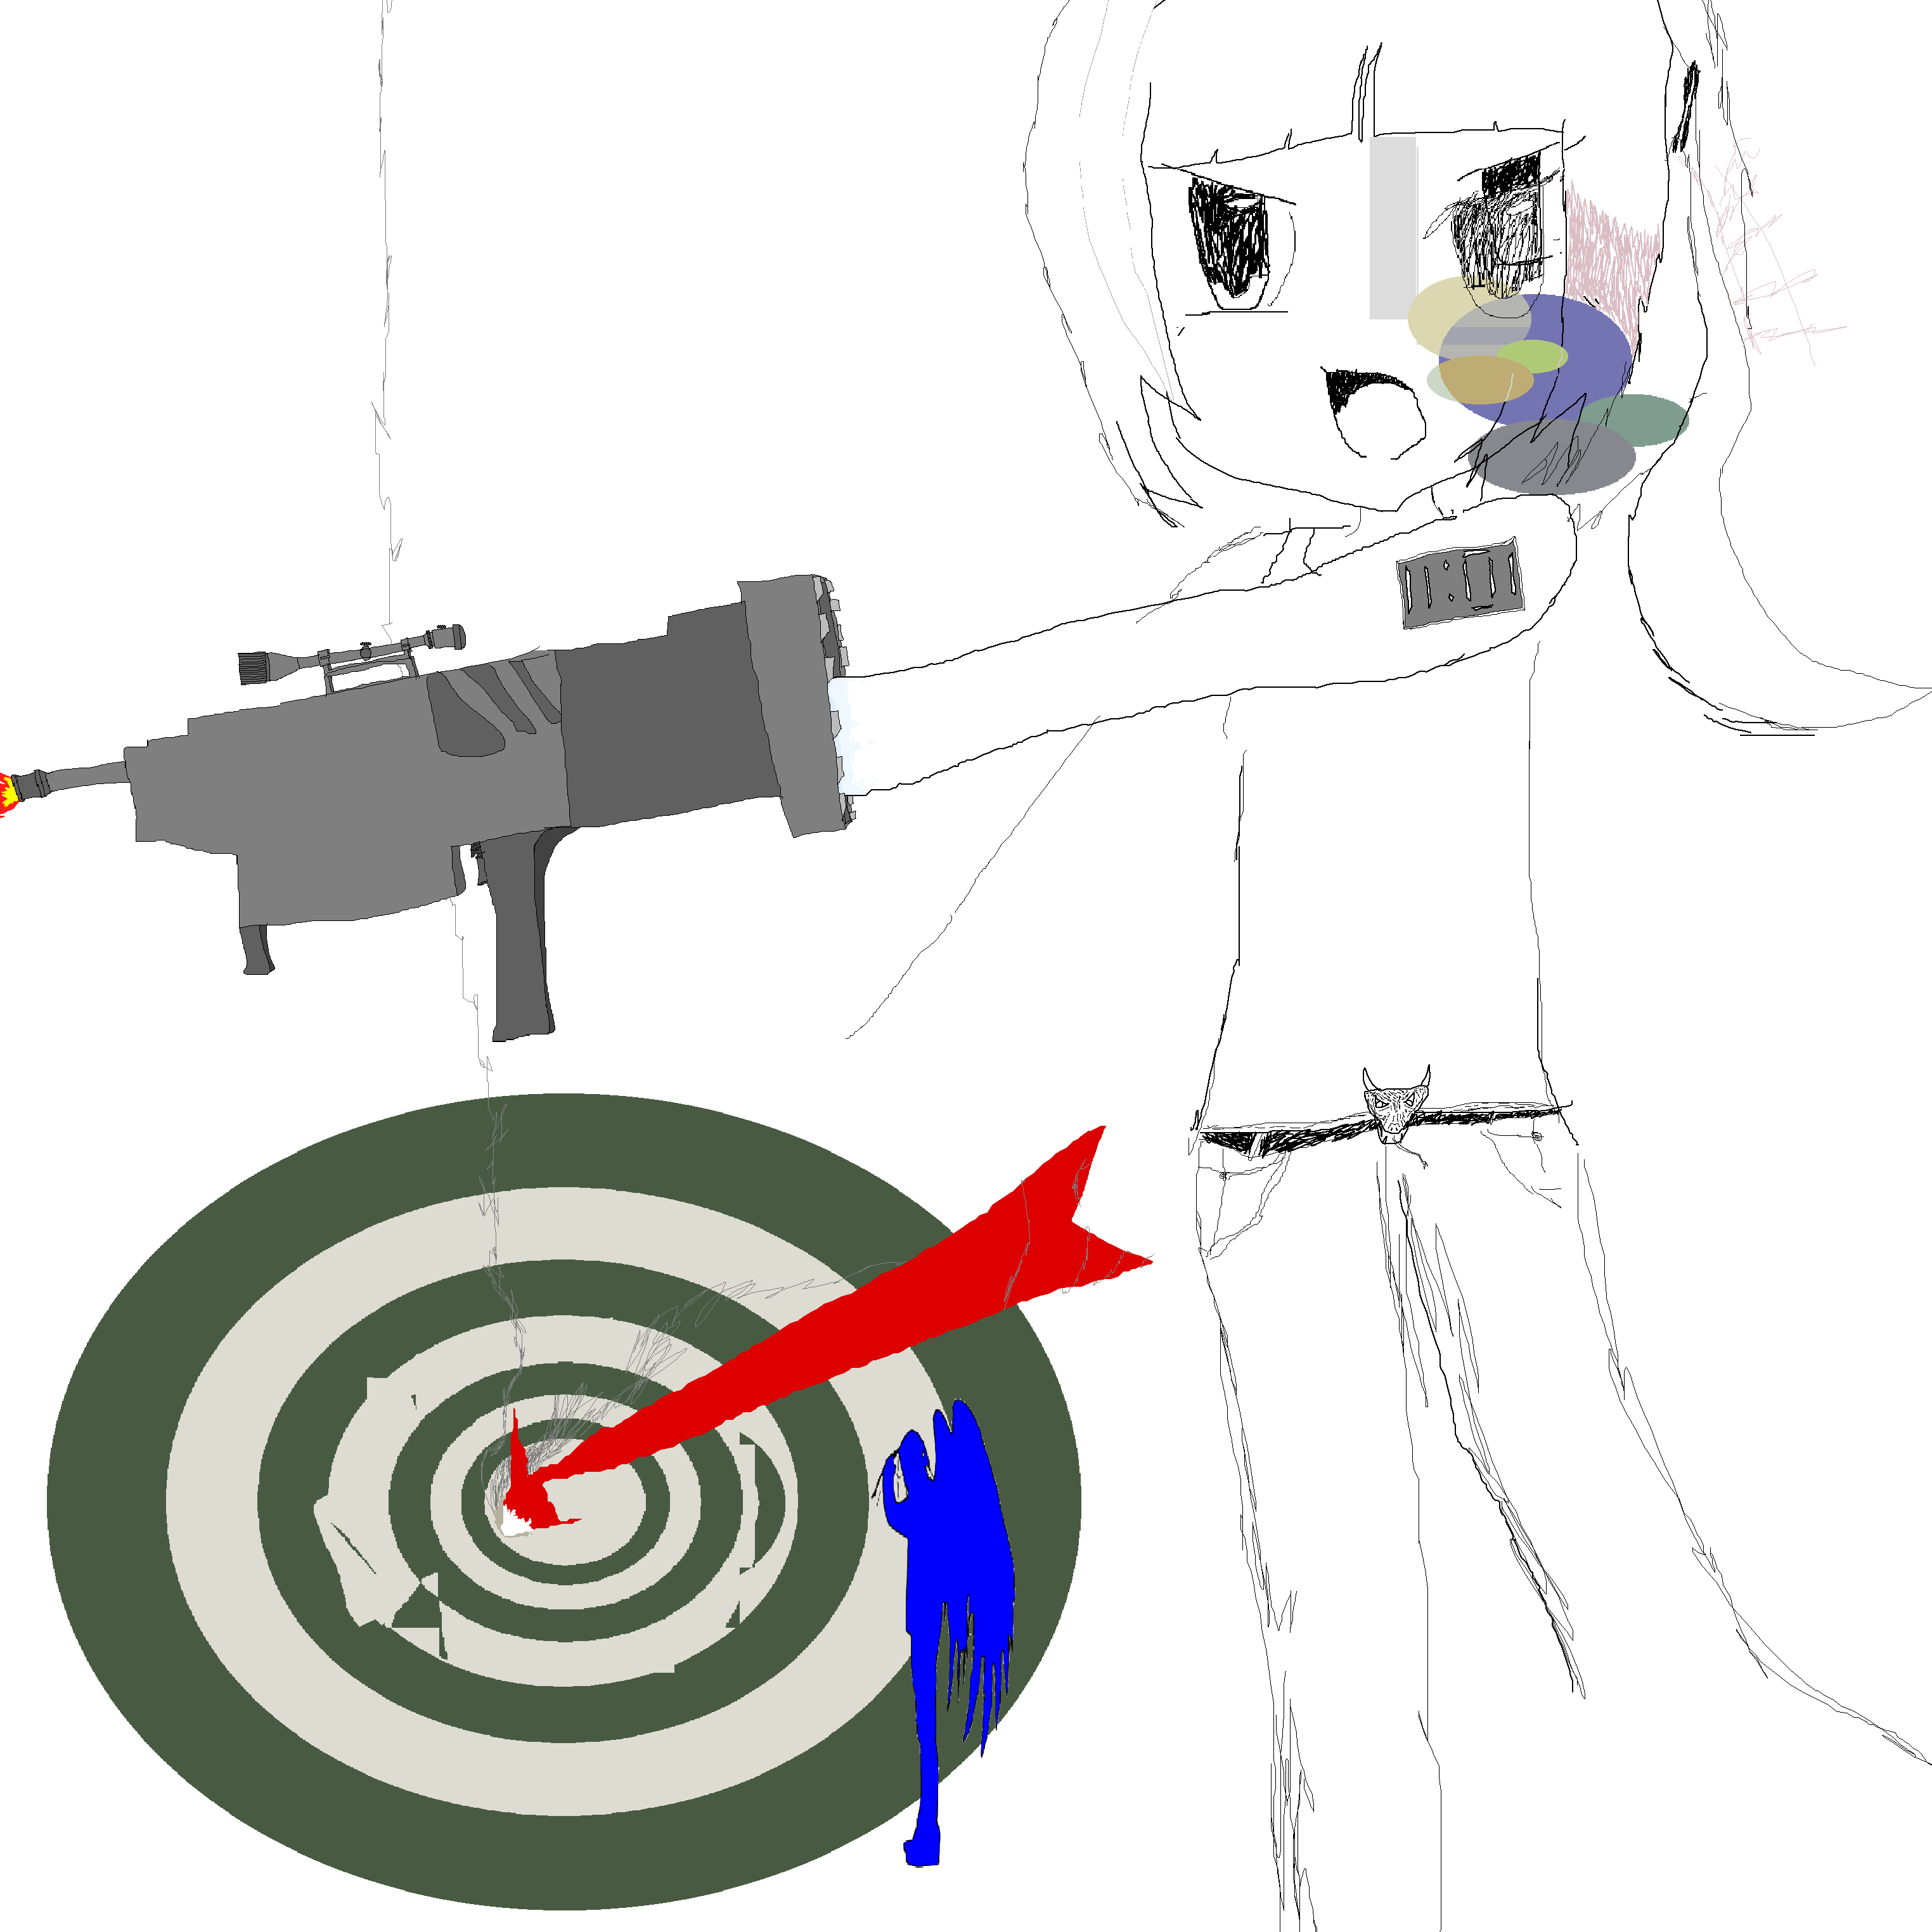
Earlier “You’ll Get Your Wealth in Heaven,” known as “My Child Was Never Born.”

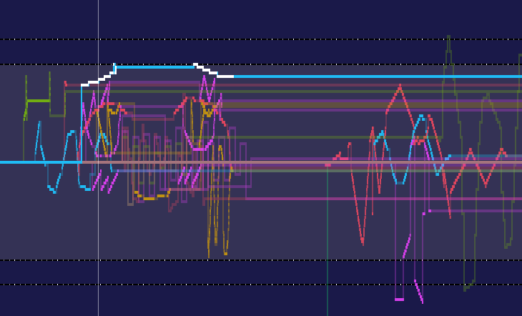
Pxtone Collab session capture.

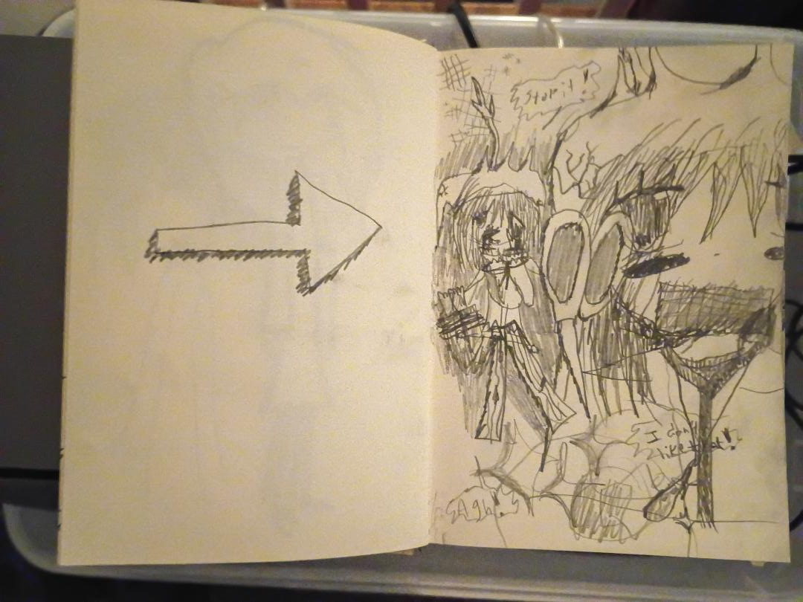
My captier.

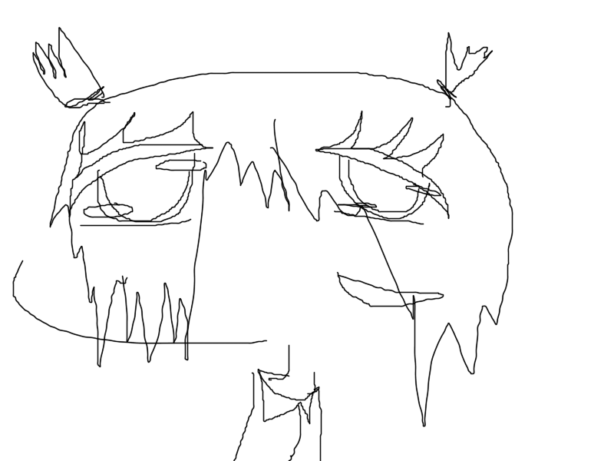
NMDA you were just up.

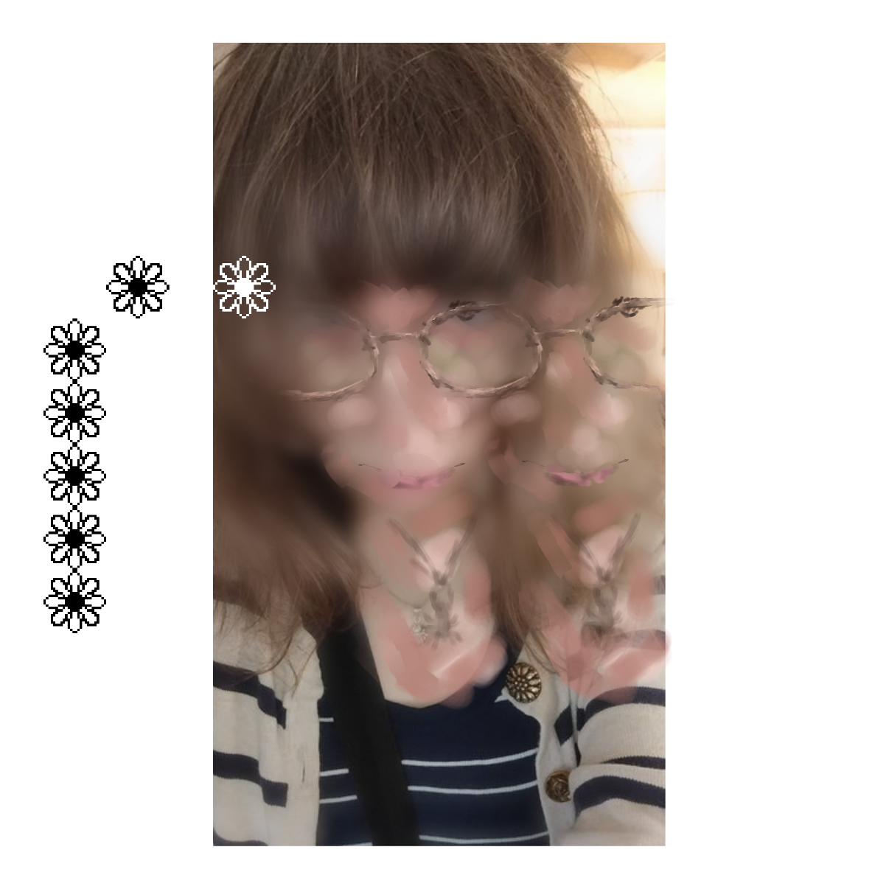
Press photo.

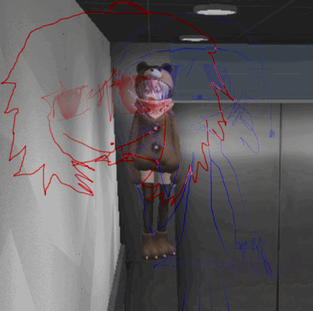
Memory, 2025.
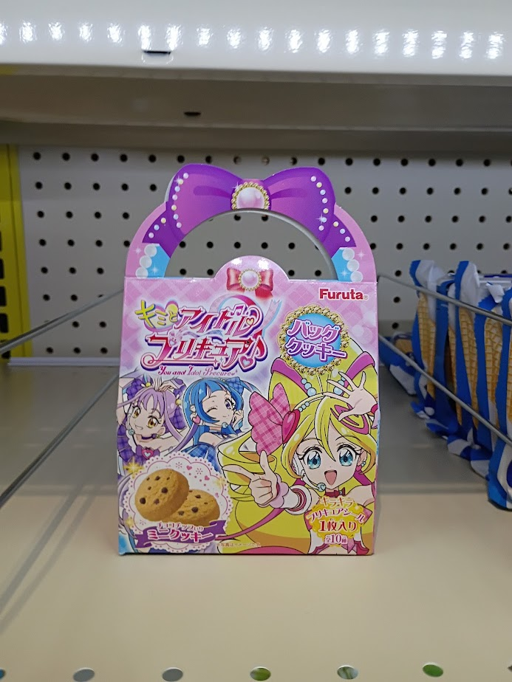
Lucky.


4) Lyrics

Chapel’s last little roe srash
[Forward]
Ah

Pa’tchtel
[Nata]
Before we were newly married
Baptized in the church
So deep in that pool
…or buried in our parents

Right as we were wedded
I couldn’t think straight at all
My head was all messed up
Had to get out some way

[JR Get Money]
(Alright) Already, the show goes on
All night, ‘til the morning we dream so long
Anybody ever wonder, when they would see the sun up?
Just remember when you COME UP

Coat’s Lament
[Nata 1, 2, and 3]
We are the coats with the denim charm
We are the coats that make for warm arms
We are the coats that keep you safe from burns
We are the coats that they wear around the world

[Nata 4]
(Aaaaaaaaaaaaaaaaaaahhhhhh)

[Nata 1, 2, and 3]
We are the coats with the corduroy necks
We are the coats that are the very best
We are the coats that make for well done work
We are the coats that you'll wear around the world

Your New Tabler (Keegan)
[Nata]
This is a glass
This is unstable
Creep at the edge
…of your new table

25% Little Star
[Nata]
I’m with you
It’s so cool
It’s so cool
We’re at school
I’m breathing
That quite good laughter
Both eyes out so
…I’m with you
It’s so cool
It’s so cool

…
[Forward]
Smoke words down oh
Smoke . . . like a new pack of cigarettes
It turiel couldn't be, less out
Just to be this careless now
(I need it all to re-ever one to need this careless song
I had never one to talisman your off

You're laying in your bed
Quiet and calm
so strummed down
You're asleep
Couldn't come down if you want
I'm trying your name
But nothing comes out
I'm trying to figure out

You're laying in my bed
Quiet and calm
Pulse is running slow
Couldn't wake if you'd want
I'm trying your eyes
But they're not coming down
I'm trying to figure out
I'm trying to figure out

I love you, you're quiet, I love you

Schxyxas Ouyres
[General Nunan]
You just crossed one of those lines

PCM
[Forward]
The car seat left out
Dropped it on the floorboard
See you in the sign
Patient on the string
Nire at the moonlight
Everything is scared hour
Facing at your afternoon
I was closer you are
From letting you go
Nothing to do
I was closer then
Faces back home
Back to there
I spend your last one out

Your Voice is Being Let Slowly
[Forward]
I was in a well, trapped in the water
I’m in the background, all grey weather
The road I took to your house: it was long enough
Snow piled on my truck, it was freezing cold

I was all alone past September
I lost a war with myself in October
I felt the urge to leave, I felt the same again
I’ll fly, I’ll get away in December

Camera’s on, so baby hear me out
I’m on the floor already, so don’t beat me down
I get up, and I don’t feel okay
I’m used to change, but it’ll stay the same

I’m on airplane mode
Don’t fuck with me
I can’t take you home

5) Digital download & bonus

If you did not receive an MP3 download with your disc, you can download one at …
Using your code on the paper slip in the plastic outer CD sleeve.
DJ Lifty Forward live (January & July ‘26) recordings are available for CD purchase and MP3 download, please send a message if you are interested.
Thank you forever and always.

